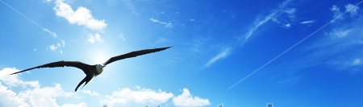
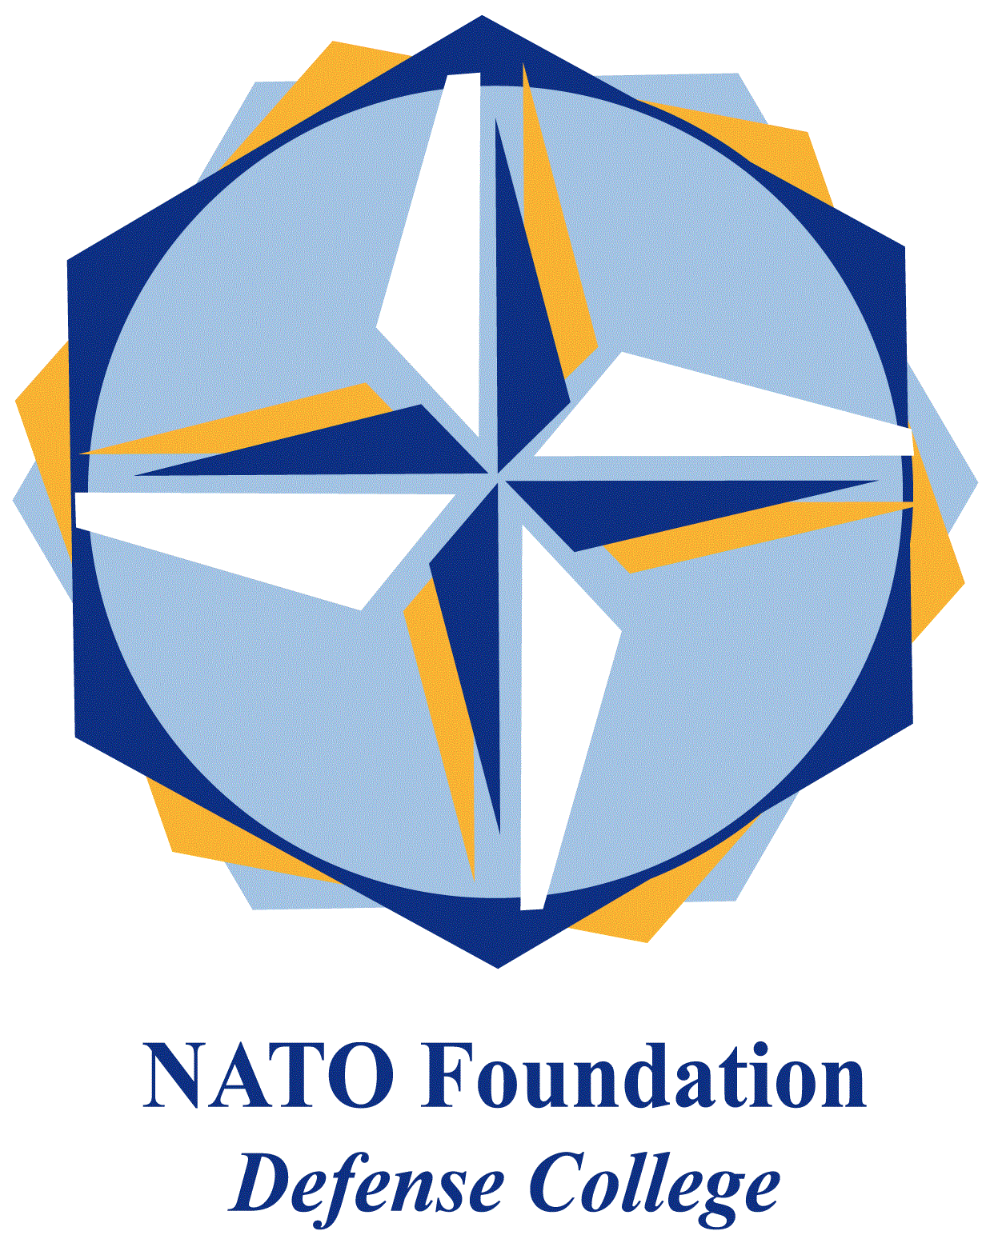
NATO DEFENSE COLLEGE FOUNDATION
STRATEGIC TRENDS
September 2015
RUSSIA
Little cold war in Syria
In late September, an impressive number of presidents and prime ministers gathered at the United Nations Headquarters for the opening of this year’s 70th annual session. Each has their own national interest and agenda to pursue, of course, but few dispute that the crisis which overwhelms all others is the agony of Syria, and the Syrians.
UN’s dominant body, the Security Council, has been impotent in the face of more than three years of civil war. That happens precisely because the most powerful members of the Security Council, Russia and the United States, are on opposite sides in the Syrian war. President Putin increasingly arms and supports Syrian President Bashar al-Assad and his embattled government in Damascus. President Obama and his Western allies call Mr Assad a war criminal and a butcher.
When Mr Obama sat down with Mr Putin in New York on September 28, after almost a year without face-to-face contact, expectations were already low. In the event, the two leaders opened with a brief, unsmiling handshake for the cameras. They barely made eye contact, revealing the gulf between them, before disappearing for talks.
An American official said the two men met for about 90 minutes and apparently spent half their time discussing Syria, the other half on Ukraine. The Americans say the two sides fundamentally disagreed on the role that President Assad would play in resolving the civil conflict there. The Russians see Mr Assad as a bulwark against extremists; the Americans see him as continuing to fan the flames of sectarian conflict in Syria.
So how about this for understatement? “I think the Russians certainly understood the importance of there being a political resolution in Syria and there being a process that pursues a political resolution” said the American side. “We have a difference about what the outcome of that process would be” particularly as it relates to Mr Assad, they said.
Not exactly the same narrative, according to the Russian version of the story. President Putin himself spoke to Russian reporters, as if to emphasize the confidence he apparently feels about his position. He told them that Russia had not ruled out air strikes in support of Syrian forces fighting Islamic State militants and was thinking about how to strengthen further the Syrian army. Something that punctually happened
Mr Putin pointedly said any Russian strikes would respect international norms such as a request from Syria’s government. Besides, it is rather clear the West is willing to climb down from its previous insistence that President Assad had to go before - not during - any process of transition to end the civil war.
This concession is quite distasteful to the United States and their allies. It also seems to contradict the Western logic which argues that Mr Assad cynically and deliberately gave space to extremists in Syria, including the Islamic State (Dawla).
But the real question is: Who is now the larger enemy of the West? From an American perspective, it is no longer Mr Assad, however much he may profit from the particular horrors the IS has unleashed.
All this leaves apparently Washington somehow reliant on Russia’s political co-operation, hoping Moscow will eventually ease Mr Assad from power, even if it clearly will not drive him out. The problem for the United States is that Mr Putin does not seem to be following that script, not yet at least. The little cold war goes on.

